Bookmark App

This website aims to build the bookmark app which gives the service of saving a site’s website with title, multiple tags, description and site visiting link, which helps the user to save their favorite web site or frequently used website information at one place without having to type and search it again and again. This app also gives the functionality of updating and deleting bookmarks, with searching of bookmarks by title as well as tags.

* Technologies used :

1. Front-End : React JS, CSS
2. Back-End : Node JS,Express JS
3. DataBase : MongoDB

* GitHub Link : <https://github.com/Sudhanva-Nadiger/Book-Mark-App>

Screenshots Of the The UI and Functionalities :

* The Home page

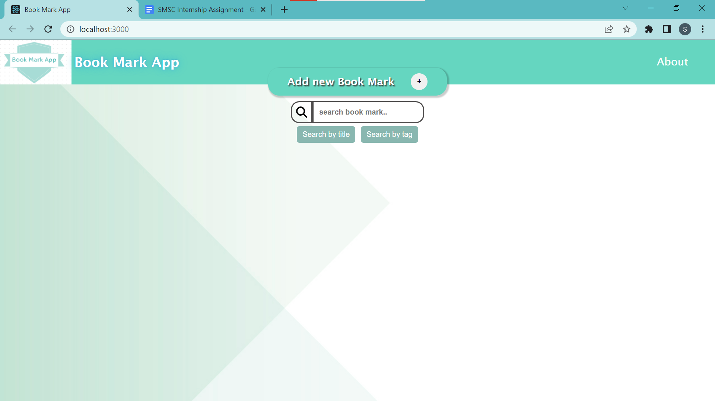

* “About” on hover card pop up information:

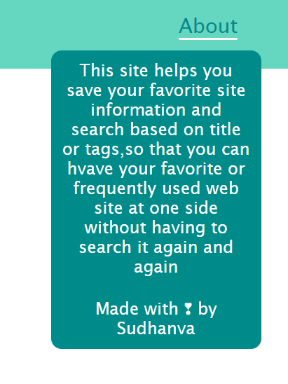

* Adding new bookmark

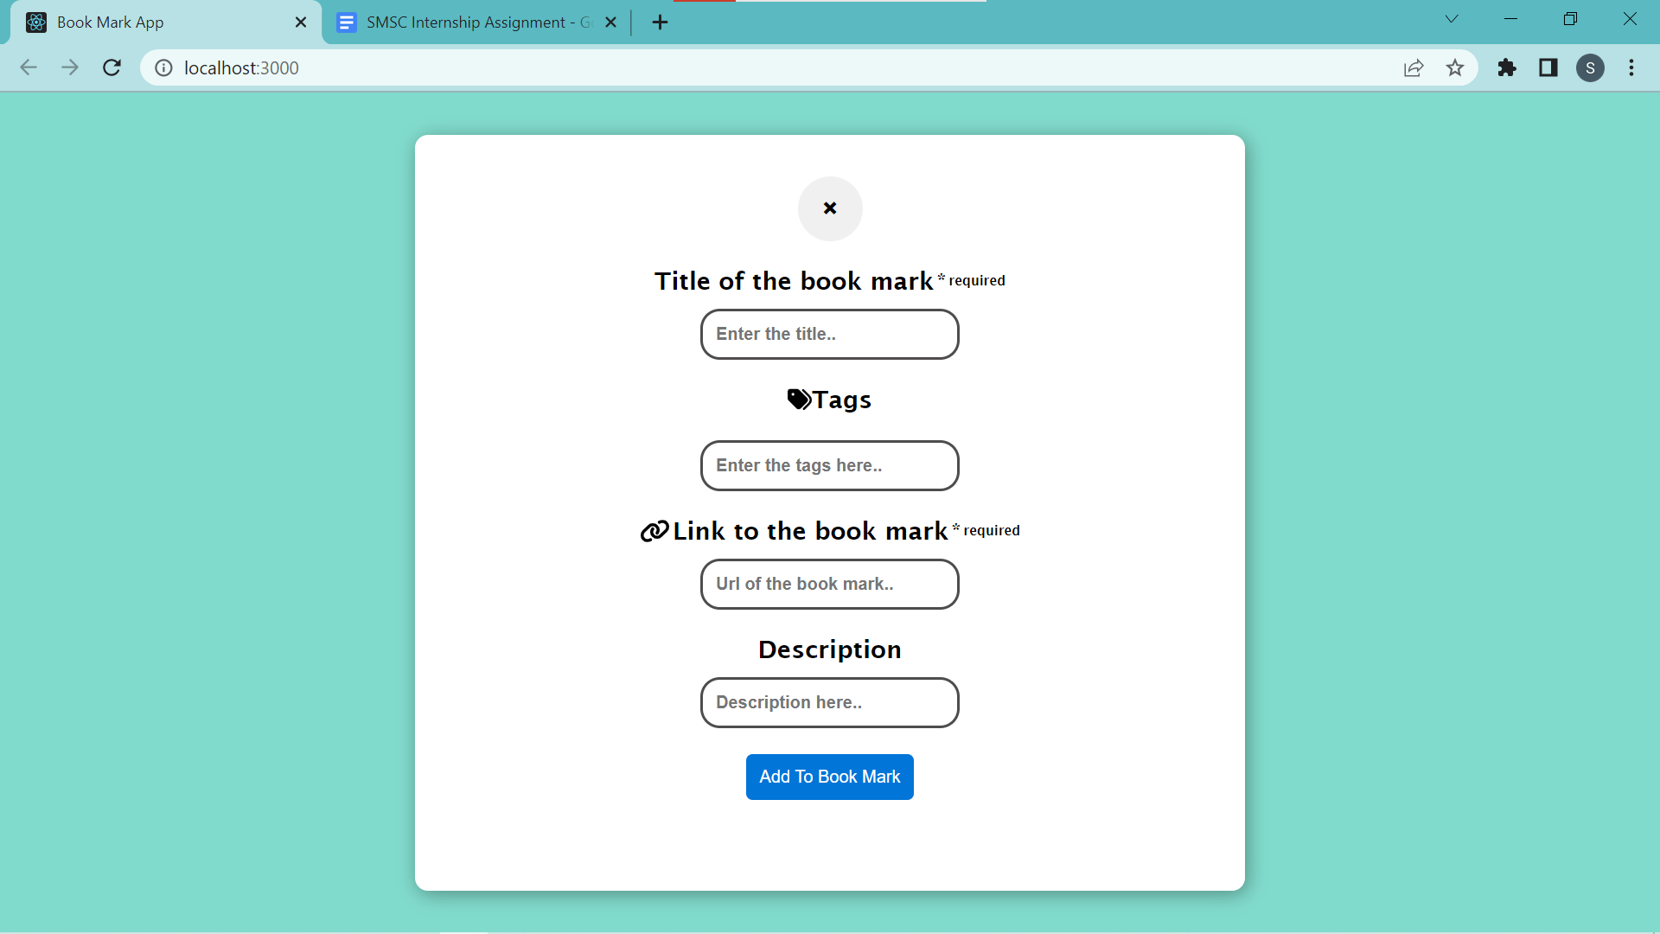

* Displaying the bookmark as a Card element

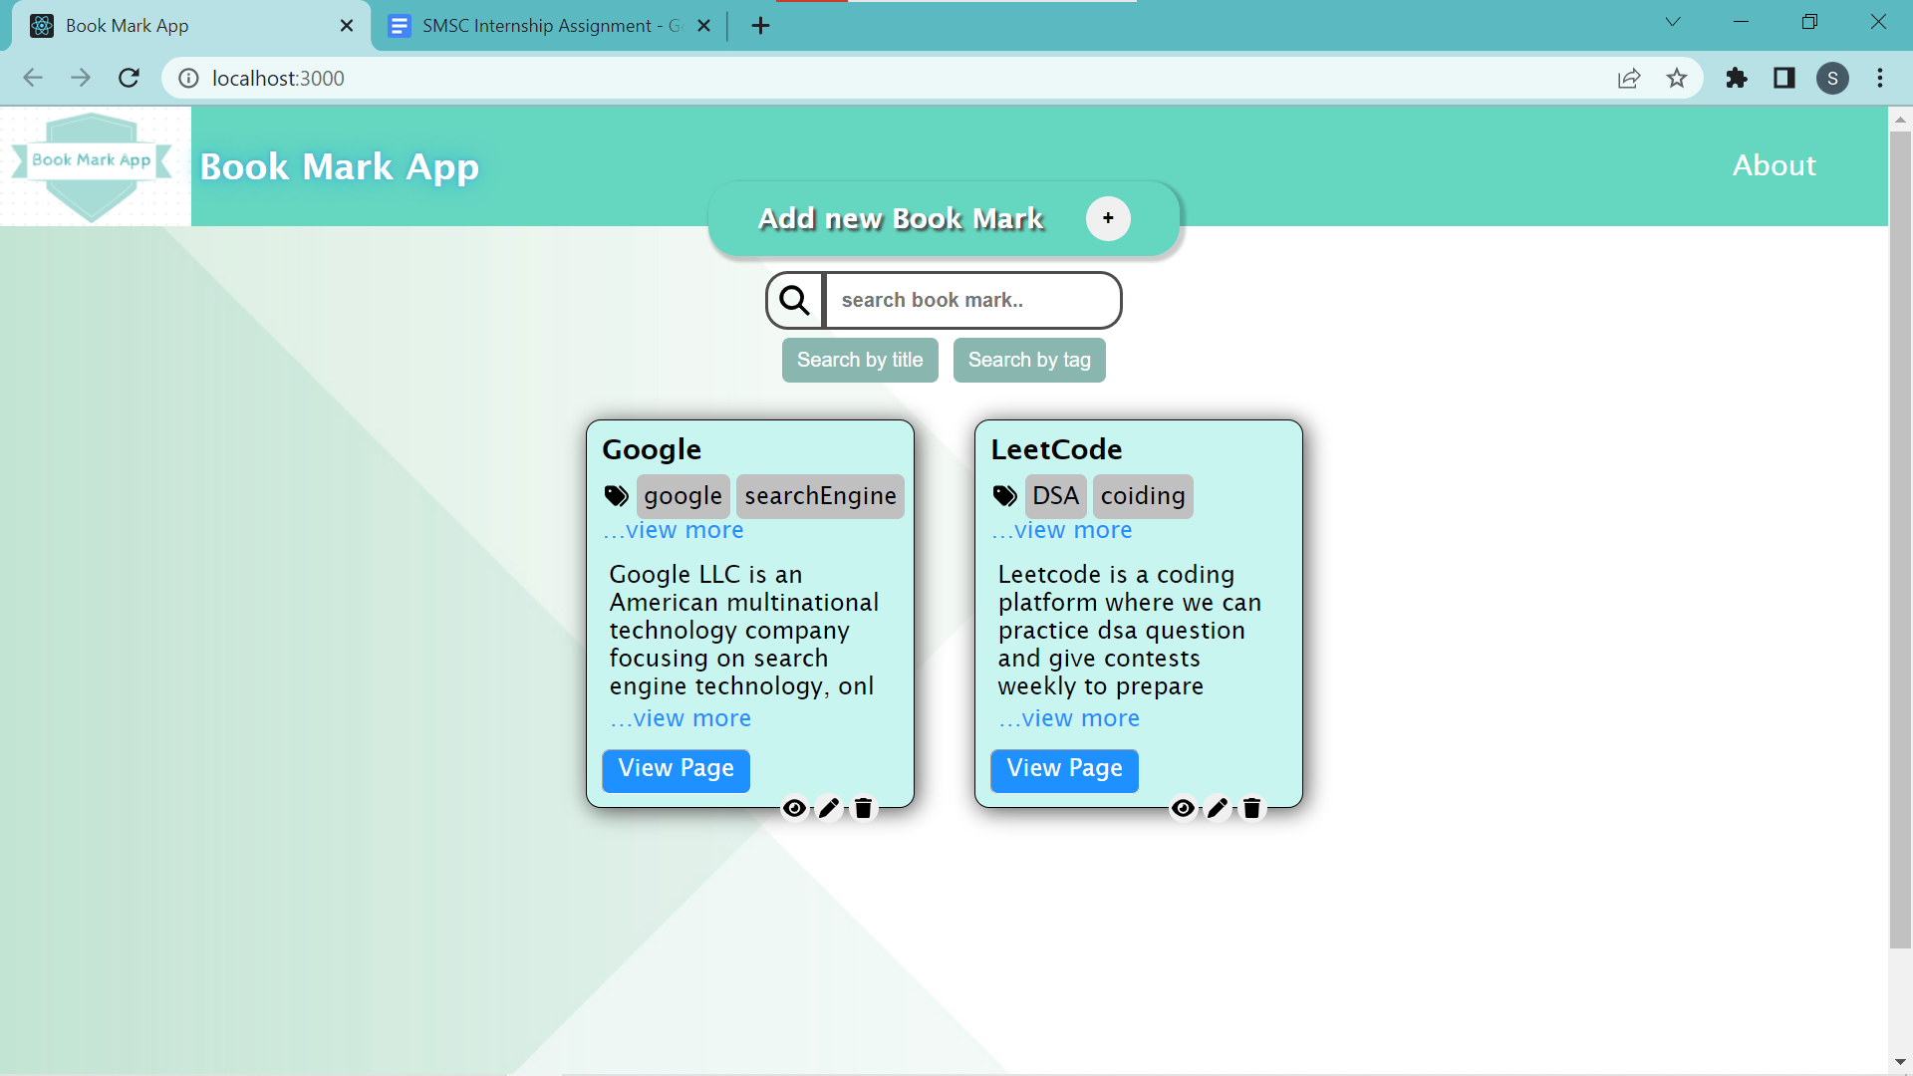

* Operations provided

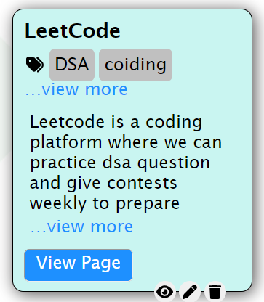

* …View more : Makes the card bigger and opens as modal

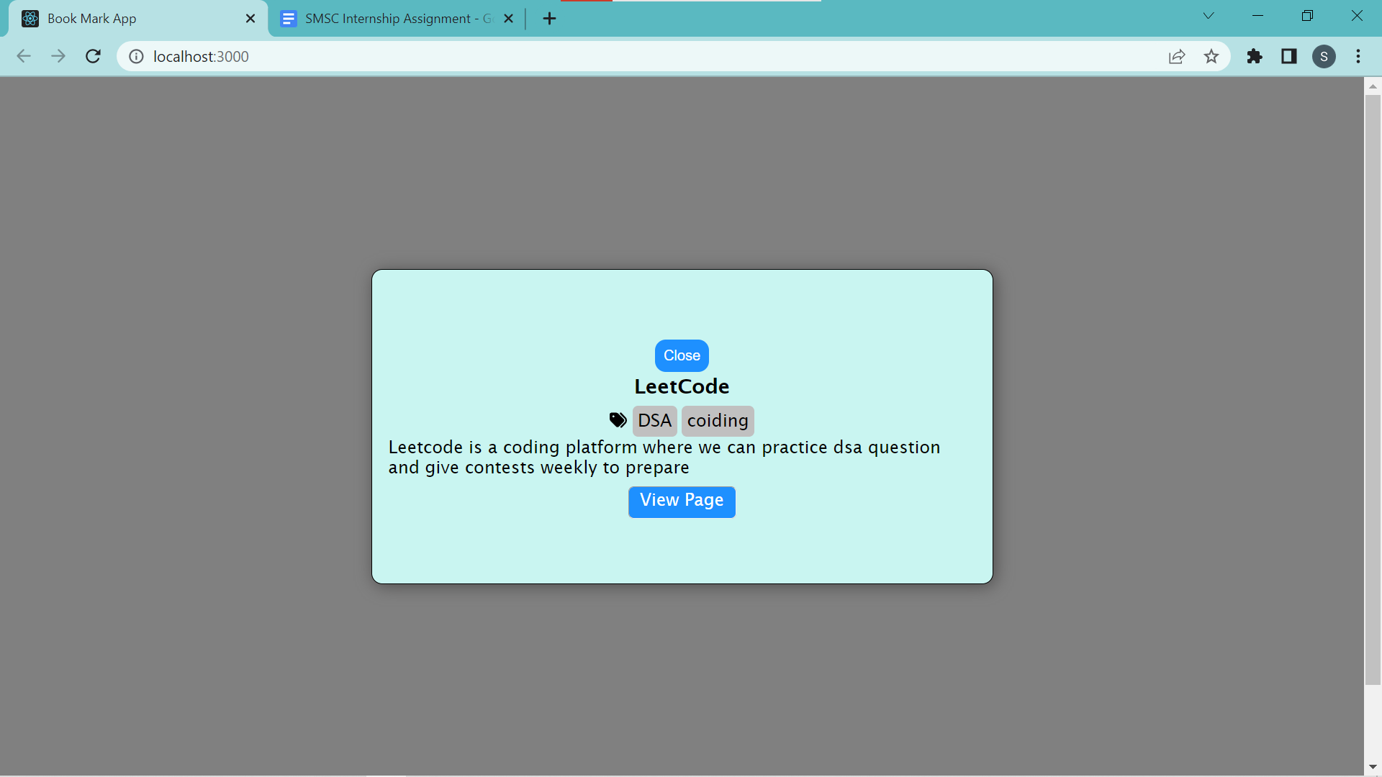

* View Page : Navigates to the web site
* Close button : Back to previous display
* Updation :
* Pen symbol at the bottom of the card is given for updation of the bookmark card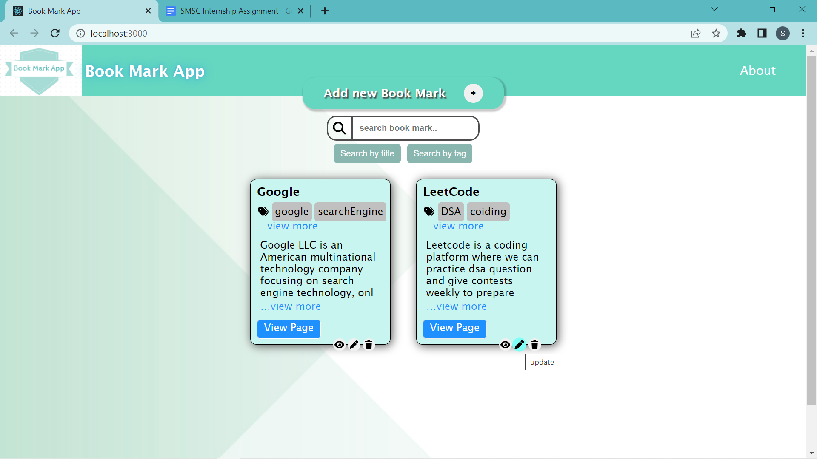
* onClick it will show the update page

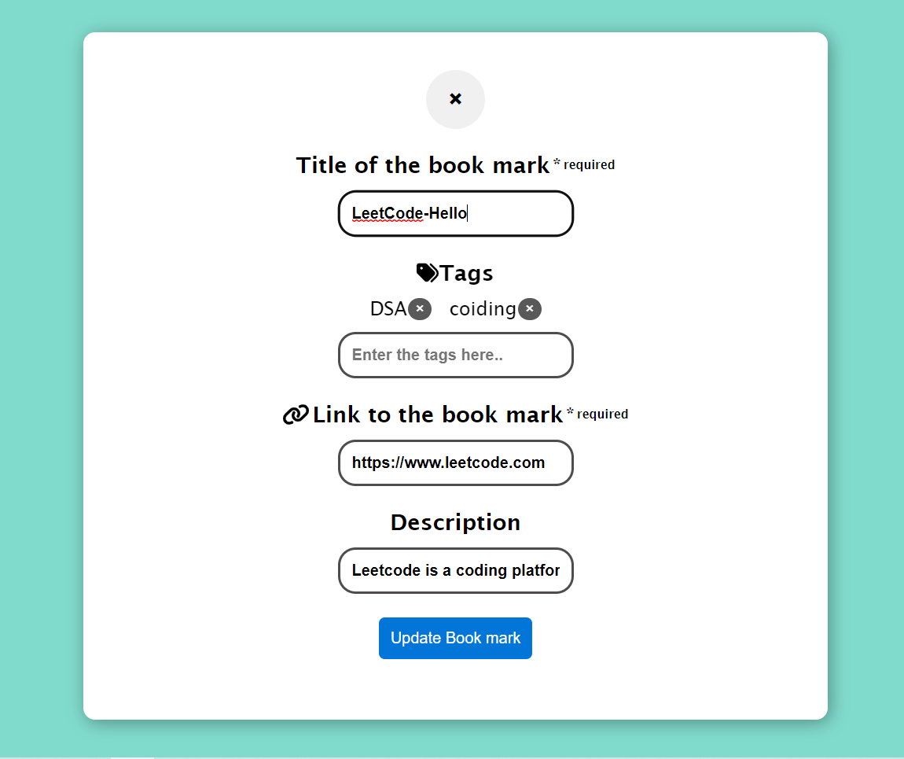

* on updating it will update the card in the database and also in the book mark card

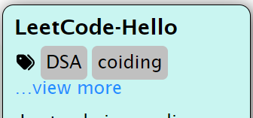

* Delete Operation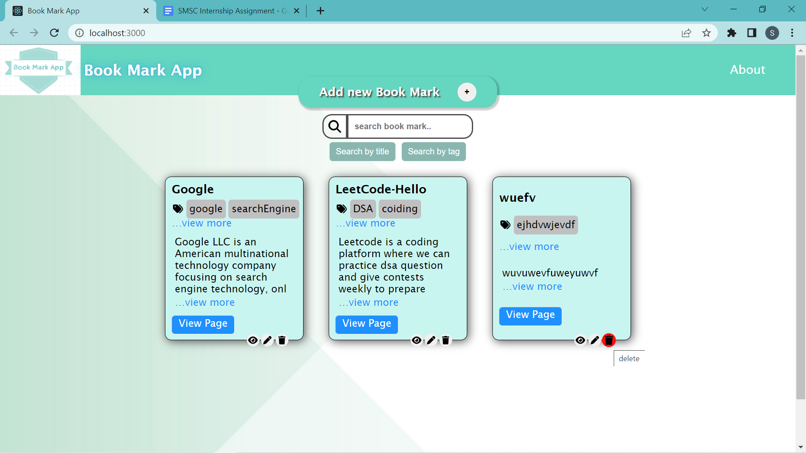
* Onclick it will ask for the confirmation and if the answer is yes it will delete the card

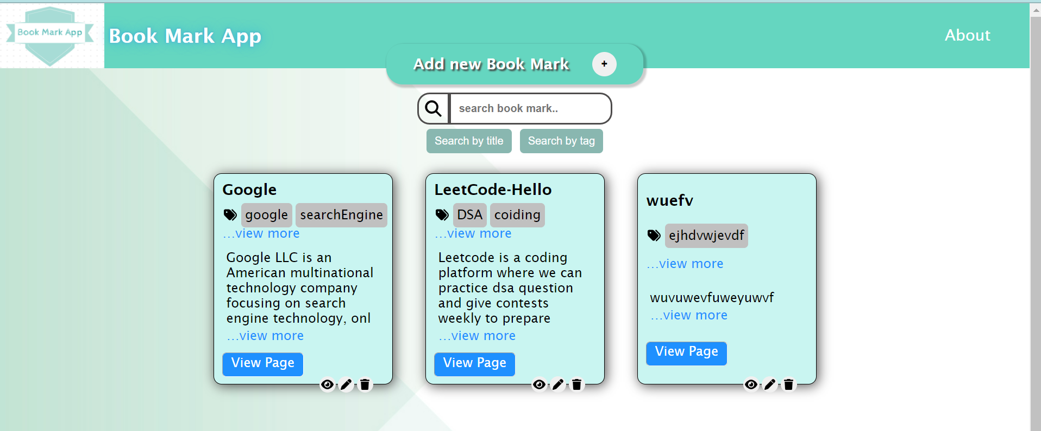

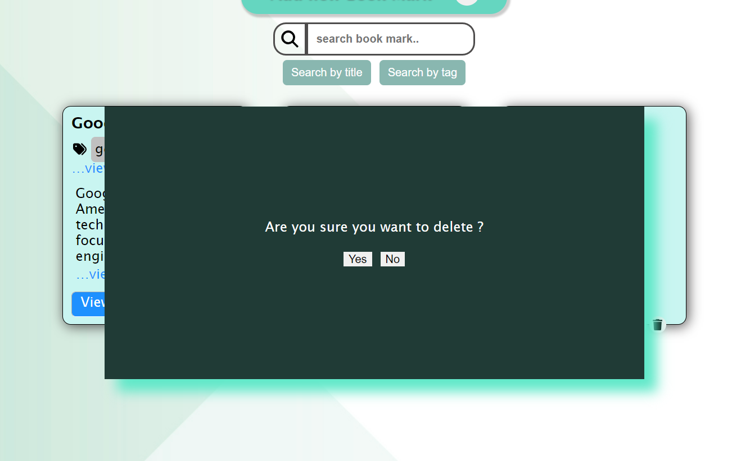

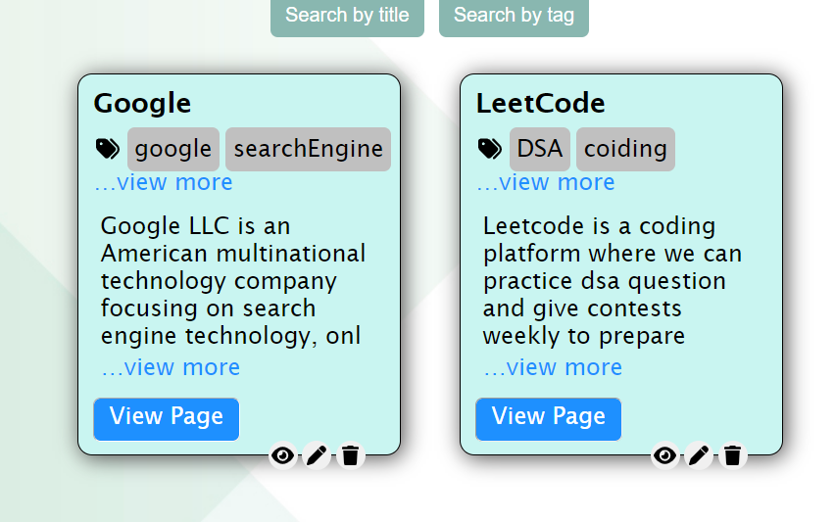

* Search Functionality

1. Search By Title : 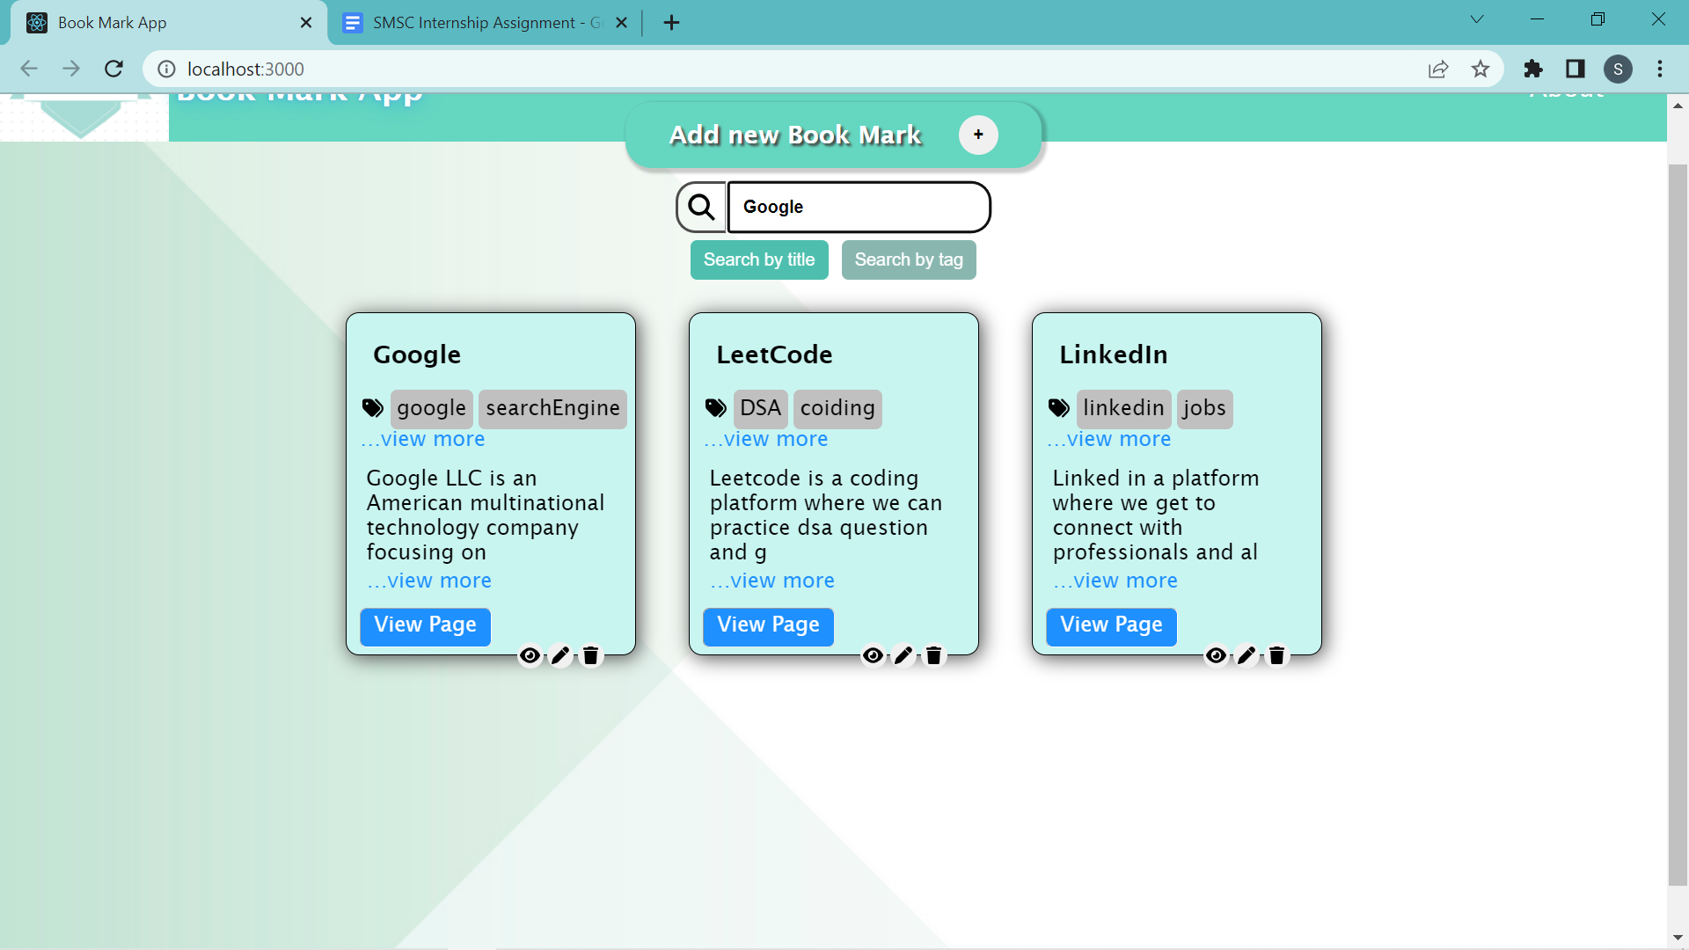

* Search will filter the bookmarks based on the search query.
* Back to home page will take to the original page

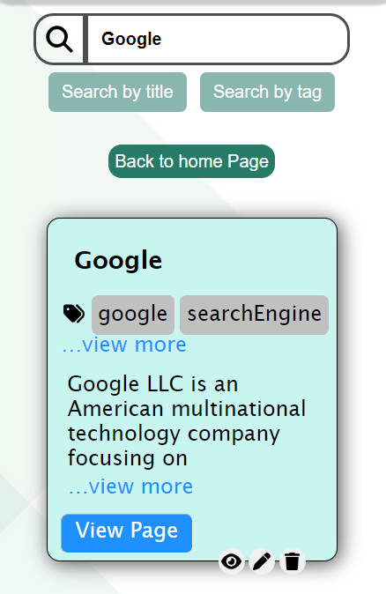

1. Search by tags

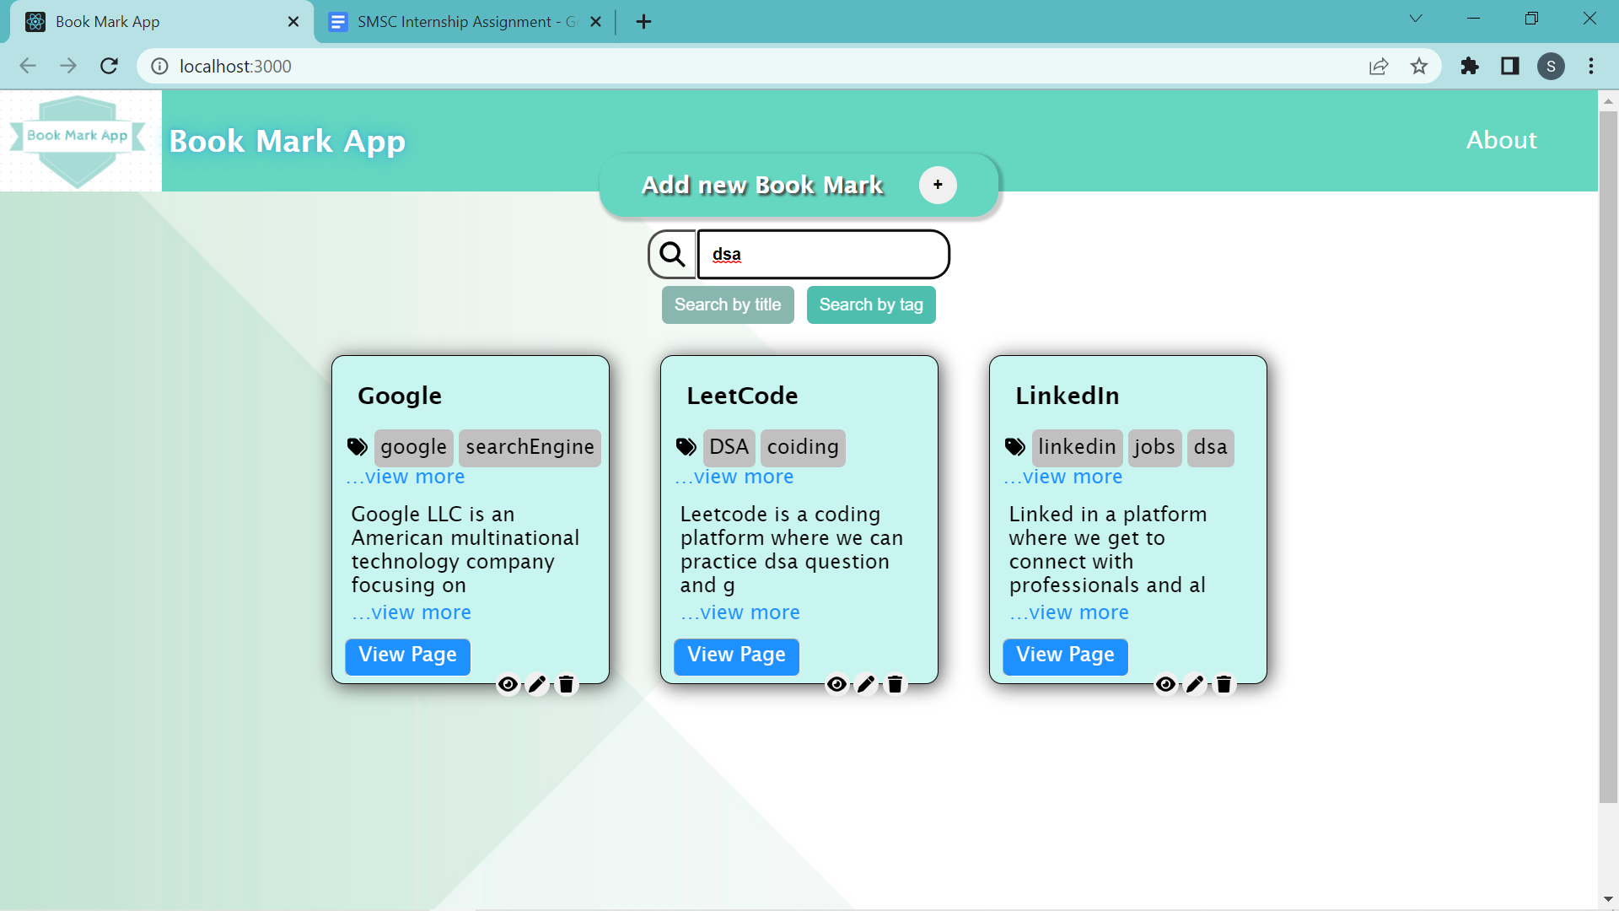

* Based on the search query the result will be filtered and renders on the screen

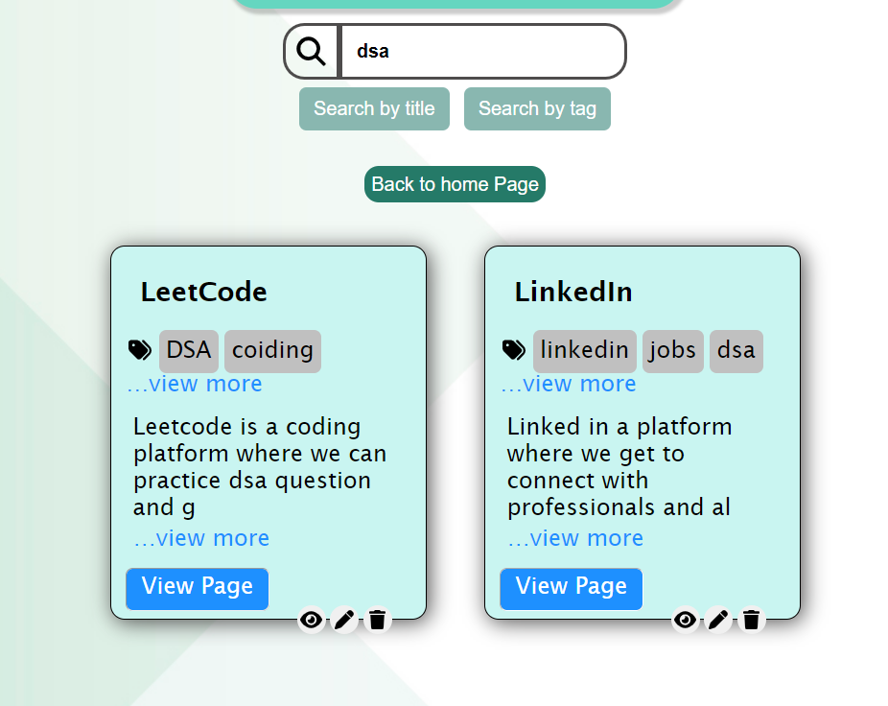

With regards

Sudhanva Nadiger,

3rd year undergrad at NIT Surathkal, Karnataka.

* Mail Id : [sudhanvanadiger12@gmail.com](mailto:sudhanvanadiger12@gmail.com), [SUDHANVA BHISHTHESHA NADIGERA](mailto:sudhanvabhishtheshanadigera.201me157@nitk.edu.in)
* GitHub :<https://github.com/Sudhanva-Nadiger>
* LeetCode : <https://leetcode.com/sudhanva_nadiger__/>
* LinkedIn : <https://www.linkedin.com/in/sudhanva-nadiger-b616a6212/>

Thank You